UNIT-1
Introduction
Data Structures:
A data structures is basically a group of data elements that are put together under one name, and which defines a particular way of storing and organizing data in a computer. So that it can be used efficiently.
Classification of Data structures:
Data structures are generally categorized into two classes
- Primitive Data Structures
- Non-primitive Data Structures.
Primitive Data Structures:
Primitive data structures are the fundamental data types which are supported by a programming language. Some basic data types are integer, real, character, Boolean.
Non-primitive Data Structures:
Non-primitive data structures are those data structures which are created using primitive data structures.
Examples: stacks, Queues, linked lists, trees, graphs.
Linear Data Structures:
If the elements of a data structures are stored in a linear or sequential order, then it is called linear data structures.
Ex: stacks, Queues, Linked lists.
Non-linear Data Structures:
If the elements of a data structures are not stored in a linear order, then it is called non-linear data structures.
Ex: Trees, Graphs.
Operations on Data Structures:
Different operations that can be performed on the various data structures
- Traversing: to access each data item exactly once. So that it can be processed.
- Searching: to find the location of one or more data items that satisfy the given constraints, such a data item may or may not be present in the given collection of data items.
- Inserting: to add data items to the given list of data items.
- Deleting: to remove (delete) a particular data item from the given collection of data items.
- Sorting: data items can be arranged in some order like ascending or descending order.
- Merging: list of two sorted data items can be combined to form a single list of sorted data items.
Abstract Data Type (ADT):
Abstract datatype is a type for objects whose behavior is defined by a set of value and a set of operations.
The definition of ADT only mention what operations are to be performed but not how these operations will be implemented. It does not specify how data will be organized in memory and what algorithms will be used for implementing operations.
Example: Array ADT
For all A∈Array, i∈index, x∈item, j, size∈integer
Array Create (j, list) := return an array of j dimension
Item Retrieve (A, i) := if(i∈index)
return item associated with index value I in an array A
else return error
Array Store (A, i, x) := if(i∈index)
return an array that is identical to array A except the new pair (i, x) has been inserted.
else return error.
end Array.
Algorithm:

An algorithm is a finite set of instructions. In addition, all algorithms must satisfy the following criteria

- Input: Zero or more quantities are externally supplied.
- Output: At least one quantity is produced.
- Definiteness: Each instruction is clear and Un-ambiguous.
- Finiteness: If we trace out the instructions of an algorithm, then for all cases the algorithm terminates after a finite number of steps.
- Effectiveness: Each instruction must be very basic.

Performance Analysis:

The efficiency of an algorithm can be decided by measuring the performance of an algorithm.
We can measure the performance by computing two factors:
- Space Complexity.
- Time Complexity.

Space complexity:
The space complexity of an algorithm is the amount of memory required to run to completion.
To compute this space complexity we use two factors:
- fixed part
- variable part
fixed part:
A fixed part that is independent of the characteristics of the inputs and outputs. This part includes the instruction space(space for code), space for simple variables and fixed size component variables, space for constants and so on.
Variable part:
A variable part that consists of the space needed by component variables whose size is dependent on the particular problem instance being solved, the space needed by the reference variables and recursion stack space.
Space requirement s(p) of any algorithm p can be given as
s(p) = c + Sp
where c is a constant i.e., fixed part Sp is a space depend upon instance characteristics .
Time Complexity:
Time complexity of an algorithm is amount of computer time required by an algorithm to run to completion.
Time T(P) taken by a program P is the sum of the compile time and the run time.

Time complexity Examples :-

- Sum of an array elements

 | Statement | s/e | frequency | Total steps
1 | Algorithm sum(a, n) | 0 | 0 | 0
2 | { | 0 | 0 | 0
3 | s := 0; | 1 | 1 | 1
4 | for i := 1 to n do | 1 | n+1 | n+1
5 | s = s + a[i]; | 1 | n | n
6 | return s; | 1 | 1 | 1
7 | } | 0 | 0 | 0
Total = |  | 2n+3

- Matrix addition

 | Statement | s/e | frequency | Total steps
1 | Algorithm add(a, b, c, m, n) | 0 | 0 | 0
2 | { | 0 | 0 | 0
3 | for i := 1 to m do | 1 | m+1 | m+1
4 | for j := 1 to n do | 1 | m(n+1) | m(n+1)
5 | C[i, j] = a[i, j] + b[i, j]; | 1 | mn | mn
6 | } | 0 | 0 | 0
Total = |  | m+1+mn+m+mn= 2mn+2m+1

- Matrix Multiplication

 | Statement | s/e | frequency | Total steps
1 | Algorithm mul(a, b, c, n) | 0 | 0 | 0
2 | { | 0 | 0 | 0
3 | for i := 1 to n do | 1 | n+1 | n+1
4 | for j := 1 to n do | 1 | n(n+1) | n²+n
5 | { | 0 | 0 | 0
6 | c[i , j] = 0; | 1 | n² | n²
7 | for k := 1 to n do | 1 | n²(n+1) | n³+n²
8 | c[i, j] = c[ i , j] + a[i, k] * b[k, j]; | 1 | n³ | n³
9 | } | 0 | 0 | 0
10 | } | 0 | 0 | 0
Total = |  | 2n³+3n²+2n+1

- Recursive sum of array elements

 | Statement | s/e | frequency  n=0 n>0 | Total steps  n=0 n>0
1 | Algorithm Rsum(a, n) | 0 | 0 0 | 0 0
2 | { | 0 | 0 0 | 0 0
3 | if (n <= 0) then | 1 | 1 1 | 1 1
4 | return 0; | 1 | 1 0 | 1 0
5 | else | 0 | 0 0 | 0 0
6 | return Rsum(a, n-1) + a[n ]; | 1+x | 0 1 | 0 1+x
7 | } | 0 | 0 0 | 0 0
Total = |  |  |  | =2 =2+x

where x = Trsum(n-1)

Trsum(n) = 2 if n=0
2+Trsum(n-1) if n>0

Trsum(n) = 2 + Trsum(n-1)
=2 + 2 + Trsum(n-2) = 2.2 + Trsum(n-2)
=2.2 + 2 + Trsum(n-3) = 3.2 + Trsum(n-3)

n times

=n.2 + Trsum(0) = n.2 + 2
=2n + 2.

ASYMPTOTIC NOTATIONS :

- To choose best algorithm we use space complexity and time complexity.
- There are 3 types . There are

- Big - Oh (O)
- Big - Omega (Ω)
- Big - Theta (Θ)

Big ‘O’ notation: (Upper bound)

The function f(n)=O(g(n)) if and only if there exists positive constants c and n₀ such that
f(n) <= c*g(n) for all n, n>=n₀

Diagram :-
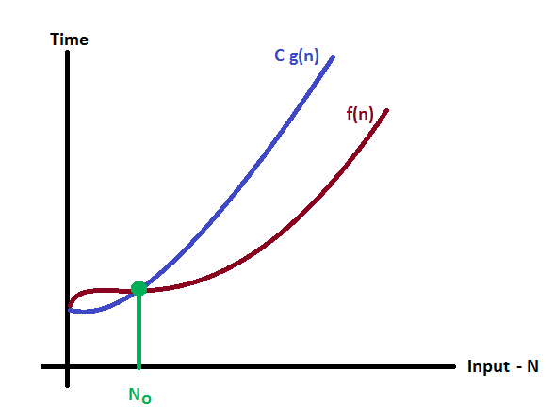

Examples:

1) Let f(n) = 3n+2
3n + 2 <= 4 * n for all n, n>=2
Here c=4 g(n) = n and n₀ = 2
Therefore, f(n) = O(n)

2) Let f(n) = 10n²+4n+2
10n²+4n+2 <= 11 * n² for all n, n >= 5
Here c=11 g(n) = n² and n₀ = 5
Therefore, f(n) = O(n²)

3) ) Let f(n) = 2n³+4n²+5n+2
2n³+10n²+4n+2 <= 3 * n³ for all n, n >= 6
Here c= 3 g(n) = n³ and n₀ = 6
Therefore, f(n) = O(n³)

ORDER OF GROWTH IS AS FOLLOWS
O(1) < O(log n) < O(n) < O(n* log n) < O(n²) < O(n³) < O(2^{n})

OMEGA 'Ω' NOTATION: ( Lower bound)
The function f(n) = Ω(g(n)) if and only if there exists positive constants c and n₀ such that
f(n)>=c*g(n) for all n, n>=n

Diagram :
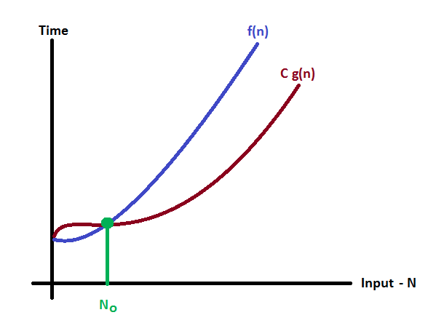

Examples:
1) Let f(n) = 3n+2
3n + 2 >= 3 * n for all n, n>=1
Here c=3 g(n) = n and n₀ = 1
Therefore, f(n) = Ω(n)

2) Let f(n) = 10n²+4n+2
10n²+4n+2 >= 10 * n² for all n, n >= 1
Here c=10 g(n) = n² and n₀ = 1
Therefore, f(n) = Ω(n²)

3) ) Let f(n) = 2n³+4n²+5n+2
2n³+10n²+4n+2 >= 2 * n³ for all n, n >= 1
Here c= 2 g(n) = n³ and n₀ = 1

Therefore, f(n) = Ω(n³)
THE ORDER OF GROWTH IS AS FOLLOWS
Ω(1) < Ω(log n) < Ω(n) < Ω(n* log n) < Ω(n²) < Ω(n³) < Ω(2^{n})

THETA 'Θ' NOTATION : (Upper bound and Lower bound)

The function f(n) = Θ(g(n)) if and only if there exists positive constants c₁, c₂ and n₀ such that
c₁*g(n) <= f(n) <= c₂*g(n) for all n, n>=n0

Diagram:
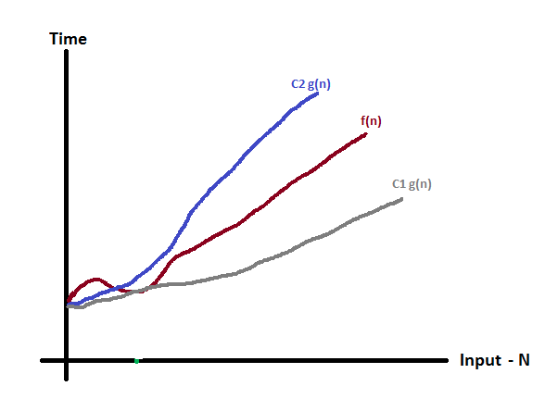

Examples:

1) Let f(n) = 3n+2
3 * n <= 3n + 2 <= 4 * n for all n, n>=2
Here c₁=3 c₂ = 4 g(n) = n and n₀ = 2
Therefore, f(n) = Θ(n)

2) Let f(n) = 10n²+4n+2
10 * n² <= 10n²+4n+2 <= 11 * n² for all n, n >= 5
Here c₁= 10 c₂ = 11 g(n) = n² and n₀ = 5
Therefore, f(n) = Θ(n²)

3) ) Let f(n) = 2n³+4n²+5n+2
2 * n³ <= 2n³+10n²+4n+2 <= 3 * n³ for all n, n >= 6
Here c₁= 2 c₂ = 3 g(n) = n³ and n₀ = 6
Therefore, f(n) = Θ(n³)

THE ORDER OF GROWTH IS AS FOLLOWS
Θ(1) < Θ(log n) < Θ(n) < Θ(n* log n) < Θ(n^2) < Θ(n^3) < Θ(2^n)

Basic Efficiency Classes

Class | Name
1 | Constant
logn | logarithmic
n | linear
nlogn | n-log-n
n² | Quadratic
n³ | cubic
2^{n} | exponential

Searching
Linear or sequential search:
This is a straight forward algorithm that searches for a given item(k) in a list of n elements by checking successive elements of the list until either a match with the search element(k) is found or the list is over.
Iterative algorithm:
Algorithm seqsrch(A[0…n-1], k)
{
i=0;
while((i<n)&&(a[i]≠k) do
i=i+1;
if(i<n) return i;
else return -1;
}

Recursive algorithm:
Algorithm recseqsrch(int a[20] , int n, int k)
{
n=n-1;
if(n>=0)
{
if(a[n]= =k) return n;
else return recseqsrch(a, n, k);
}
else
return -1;
}
Binary Search:
- Let a[i], 1<= i <= n be a list of elements that are sorted in non-descending order.
- Suppose if we have 'n' number of elements and x is the element to be searched.
- If n=1, small(p) be true then there is no requirement of applying divide and conquer, if n > 1 then it can be divided into new sub problems.
- Pick an index 'q' = (i+l)/2 in the range[i , l] and compare x with a[q] then the following 3 possibilities will occur,
  - If x=a[q], then search element found,
  - If x<a[q], then is searched in left sub list a[i], a[i+1],…,a[q-1],
  - If x>a[q], then x is searched in right sub list a[q+1], a[q+2], …., a[l]
q

a_{i,…………………………..}a_{q-1} a_{q+1 ,} ……….a_{l}

Binary Search (Iterative Algorithm)
Algorithm binsearch ( a, n, x )
{
low := 1; high := n;
while( low <= high ) do
{
mid := (low + high)/2;
if ( x < a[mid] ) then high := mid-1;
else if ( x > a[mid] ) then low := mid + 1;
else return mid;
}
return 0;
}

Binary Search (recursive Algorithm)
Algorithm Recbinsearch ( a, i, l, x )
{
if ( i = l ) then //small(p)
{
if ( a[i] = x ) then return i;
else return 0;
}
else
{
mid = ( i+l )/2;
if (x < a[mid] ) then return Recbinsearch ( a, i, mid-1, x );
else if ( x > a[mid] ) then return Recbinsearch ( a, mid+1, l, x );
else return mid;
}
}

EXAMPLE:
Consider the list n=14 where a={-15, -6, 0, 7, 9, 23, 54, 82, 101, 112, 125, 131, 142, 151}
index | 1 | 2 | 3 | 4 | 5 | 6 | 7 | 8 | 9 | 10 | 11 | 12 | 13 | 14
a[index] | -15 | -6 | 0 | 7 | 9 | 23 | 54 | 82 | 101 | 112 | 125 | 131 | 142 | 151

Using binsearch iterative algorithm
X=151(key element which has to be find)
Low high mid
1 14 (1+14)/2 = 7
8 14 (8+14)/2 = 11
12 14 (12+14)/2 = 13
14 14 (14+14)/2 = 14 found
X= -14 (key element which has to be find)
Low high mid
1 14 (1+14)/2 = 7
1 6 (1+6)/2 = 3
1 2 (1+2)/2 = 1
2 2 (2+2)/2 = 2
2 1 not found

X=9 (key element which has to be find)
Low high mid
1 14 (1+14)/2 = 7
1 6 (1+6)/2 = 3
4 6 (4+6)/2 = 5 found
Using Recbinsearch algorithm
1) X=151(key element which has to be find)
Call Recbinsearch ( a, 1, 14, 151)
Call Recbinsearch ( a, 8, 14, 151)
Call Recbinsearch ( a, 12, 14, 151)
Call Recbinsearch ( a, 14, 14, 151)
return 14
2) X= -14 (key element which has to be find)
Call Recbinsearch ( a, 1, 14, -14)
Call Recbinsearch ( a, 1, 6, -14)
Call Recbinsearch ( a, 1, 2, -14)
Call Recbinsearch ( a, 2, 2, -14)
return 0
3) X=9 (key element which has to be find)
Call Recbinsearch ( a, 1, 14, 9)
Call Recbinsearch ( a, 1, 6, 9)
Call Recbinsearch ( a, 4, 6, 9)
Call Recbinsearch ( a, 5, 5, 9)
return 5
Interpolation Search:
Interpolation search is similar to binary search. First, we take the list of elements in sorting order. The left most element y0 (a[x0]) and the right most element y1(a[x1]). The straight line passing through (x0, y0) and (x1, y1).

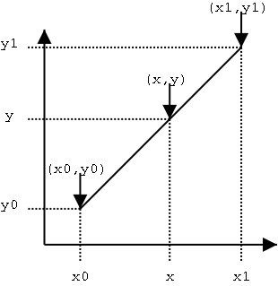
The line equation is $\frac{x-x0}{x1-x0}$ = $\frac{y-y0}{y1-y0}$
The search element y is compared with the element whose index is computed as (round off) the X-coordinate of the point on the straight line. So the point (x, y) is on the line.
x = x0 + (y - y0) ($\frac{x1-x0}{y1-y0}$)
Algorithm interpolation_search (a[1….n], int y)
{
low = 1;
high = n;
while (low ≤ high) do
{
x = x0 + (y - y0) ($\frac{x1-x0}{y1-y0}$)
if (y < a[x])
high = x-1;
else if (y > a[x])
low = x+1;
else return x;
}
return -1;
}

Fibonacci Search:
Fibonacci search is similar to Binary search and also work on sorted array. The split araay to be searched by using Fibonacci numbers.
Algorithm Fibonacci_search ( A, n, key)
{
low = 0; high = n-1; loc = -1; flag = 0;
while ((flag != 1) && (low <= high)) do
{
//get Fibonacci number < n
index = get_fibonacci(n);
if (key = = A[index + low]) then
{
flag = 1;
loc = index + low;
break;
}
else if (key > A[index + low]) then
low = low + index + 1;
else
high = low + index – 1;
n = high – low +1;
}
if (flag = = 1) then
return loc;
Else
return -1;
}

Example:
Consider the list n=10
index | 0 | 1 | 2 | 3 | 4 | 5 | 6 | 7 | 8 | 9
a[index] | 10 | 34 | 39 | 45 | 53 | 58 | 66 | 75 | 83 | 88

index | 0 | 1 | 2 | 3 | 4 | 5 | 6 | 7 | 8 | 9
Fibonacci[index] | 0 | 1 | 1 | 2 | 3 | 5 | 8 | 13 | 21 | 34

key = 88
low high loc flag index n
0 9 -1 0 -- 10
9 9 -1 0 8 1
9 1 0 return 10
Key = 10
low high loc flag index n
0 9 -1 0 -- 10
0 7 -1 0 8 8
0 4 -1 0 5 5
0 2 -1 0 3 3
0 1 -1 0 2 2
0 0 -1 0 1 1
0 1 0 return 0

Key = 35
low high loc flag index n
0 9 -1 0 -- 10
0 7 -1 0 8 8
0 4 -1 0 5 5
0 2 -1 0 3 3
0 1 -1 0 2 2
2 1 -1 0 1 0
return -1
sorting
sort:
The given list of elements are arranged in sorting (Ascending) order.
bubble Sort:
In bubble sort to compare adjacent elements of the list and exchange them if they are not in order. By doing it repeatedly, we end up “bubbling up” the largest element to the last position on the list. In the next pass bubbling up the second largest element and so on. After n-1 passes the list is sorted.
Example:
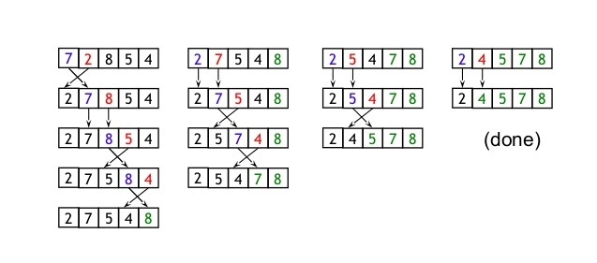
Algorithm Bubblesort (A[0…..n-1])
{
for i = 0 to n-2 do
for j = 0 to n-2-i
if (A[j] > A[j+1]) then
{
t = A[j];
A[j] = A[j+1];
A[j+1] = t;
}
}

Let C(n) = the number of comparisons required for algorithm
C(n) = $\sum_{i=0}^{n-2}{\sum_{j=0}^{n-2-i}{1}}$ = $\sum_{i=0}^{n-2}{\left(n-2-i\right)-0+1}$
= $\sum_{i=0}^{n-2}{\left(n-1-i\right)}$
= (n-1) + (n-2) + …… + 1
= $\frac{n(n-1)}{2}$ ∈ O(n²)
Bubble Sort Program:
#include<stdio.h>
void bubblesort();
main()
{
int n, i, a[100];
clrscr();
printf("\nEnter the size of array:");
scanf("%d",&n);
printf("\nEnter the elements:\n");
for(i=0;i<n;i++)
scanf("%d",&a[i]);
bubblesort(a,n);
printf("\nafter sorting elements are:\n");
for(i=0;i<n;i++)
printf("%d\t",a[i]);
getch();
}
void bubblesort(int a[],int n)
{
int i,j,t;
for(i=0;i<n-1;i++)
for(j=0;j<n-1-i;j++)
{
if(a[j]>a[j+1])
{
t=a[j];
a[j]=a[j+1];
a[j+1]=t;
}
}
}

Section Sort:
We start the selection sort by scanning the entire given list to find its smallest element and exchange it with the first element, putting the smallest element in its original position in the sorted list. Then we scan the list, starting with the second element, to find the smallest element among the last n-1 elements and exchange it with the second element, after n-1 passes the list is sorted.
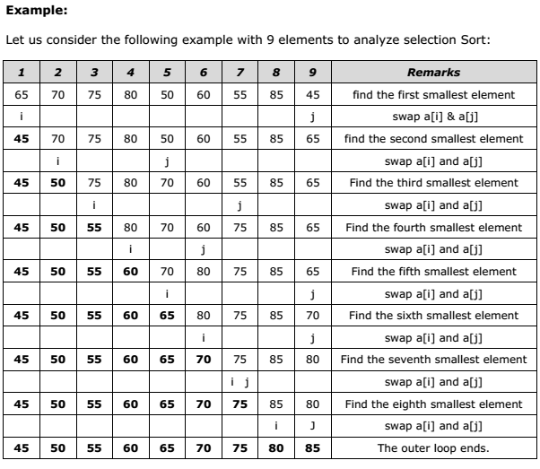

Algorithm selectionSort (A[0…..n-1])
{
for i = 0 to n-2 do
{
min = i;
for j = i+1 to n-1 do
if (A[j] < A[min]) then
min = j;
t = A[min];
A[min] = A[i];
A[i] = t;
}
}

C(n) = the number of comparisons required for algorithm.

C(n) = $\sum_{i=0}^{n-2}{\sum_{j=i+1}^{n-1}{1}}$ = $\sum_{i=0}^{n-2}{\left(n-1-(i+1\right)+1}$
= $\sum_{i=0}^{n-2}{\left(n-1-i\right)}$
= (n-1) + (n-2) + …… + 1
= $\frac{n(n-1)}{2}$ ∈ O(n²)
Program:
#include<stdio.h>
void selectionsort();
main()
{
int n,i,a[100];
clrscr();
printf("\nEnter the size of array:");
scanf("%d",&n);
printf("\nEnter the elements:");
for(i=0;i<n;i++)
scanf("%d",&a[i]);
selectionsort(a,n);
printf("\nafter sorting elements are:\n");
for(i=0;i<n;i++)
printf("%d\t",a[i]);
getch();
}
void selectionsort(int a[],int n)
{
int i,j,t,min;
for(i=0;i<n-1;i++)
{
min=i;
for(j=i+1;j<n;j++)
if(a[j]<a[min])
min=j;
t=a[min];
a[min]=a[i];
a[i]=t;
}
}

Insertion Sort:

This is an in-place comparison-based sorting algorithm. Here, a sub-list is maintained which is always sorted. For example, the lower part of an array is maintained to be sorted. An element which is to be 'inserted’ in this sorted sub-list, has to find its appropriate place and then it has to be inserted there. Hence the name, insertion sort.

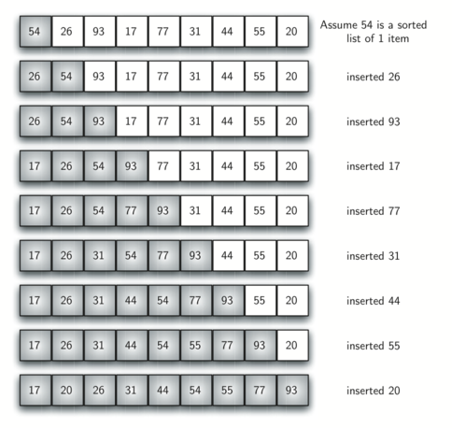

Algorithm InsertionSort (A[0….n-1])
{
for i = 1 to n-1 do
{
v = a[i];
j = i-1;
while ((j >= 0) && (A[j] > v)) do
{
A[j+1] = A[j];
j = j-1;
}
A[j+1] = v;
}
}

C(n) = The number of comparisons required for algorithm

C_{worst}(n) = $\sum_{i=1}^{n-1}{\sum_{j=0}^{i-1}{1}}$ = $\sum_{i=1}^{n-1}{\left(i-1\right)-0+1}$
= $\sum_{i=1}^{n-1}{\left(i\right)}$
= (n-1) + (n-2) + …… + 1
= $\frac{n(n-1)}{2}$ ∈ O(n²)
C_{best}(n) = $\sum_{i=1}^{n-1}{1}$ = (n-1) – 1 + 1
= (n-1) ∈ O(n)

C_{avg}(n) = $\frac{n2}{4}$ ∈ O(n²)
Program:
#include<stdio.h>
void insertionsort();
main()
{
int i,n,a[10];
clrscr();
printf("\nEnter the size of array:");
scanf("%d",&n);
printf("\nEnter the elements:\n");
for(i=0;i<n;i++)
scanf("%d",&a[i]);
insertionsort(a,n);
printf("\nafter sorting elements are:\n");
for(i=0;i<n;i++)
printf("%d\t",a[i]);
getch();
}
void insertionsort(int a[],int n)
{
int t,i,j;
for(i=1;i<n;i++)
{
t=a[i];
for(j=i-1;j>=0;j--)
if(a[j]>t)
a[j+1]=a[j];
else
break;
a[j+1]=t;
}
}

